**Setting Up Application Environment**

**Create IBM Cloud Account**

|  |  |
| --- | --- |
| Date | 24 Oct 2022 |
| Team Id | PNT2022TMID49391 |
| Project Name | News Tracker Application |

**Step 1:**

Type or click the below link in the browser ***https:***[***//www.ibm.com/academic/hom***](http://www.ibm.com/academic/home)***e***

**Step 2:**

Click the register icon.

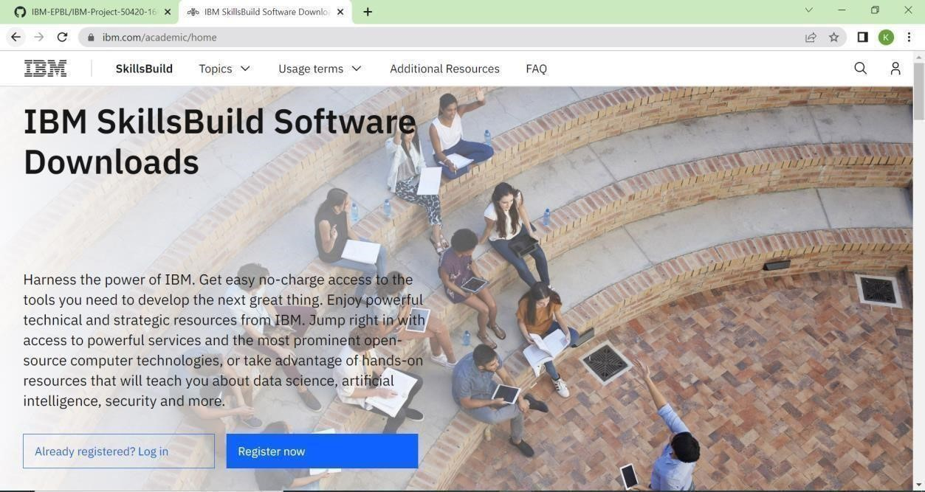

**Step 3:**

Already you got SI EMAIL and SI PASSWORD from your IBM student login.

Login to your web mail account. Wait for 7-digit verification code in your web mail: ***https://sg2plmcpnl496936.prod.sin2.secureserver.net:2096/***

**Step 4:**

Get a 7-digit verification code in webmail, then go to the registration page and enter the verification code.

**Step 5:**

Now, you have successfully created the IBM Cloud Account.

**Step 6**:

Go to IBM Cloud login page: ***https: //cloud.ibm.com/login*** ,then enter your IBM Id and Password.

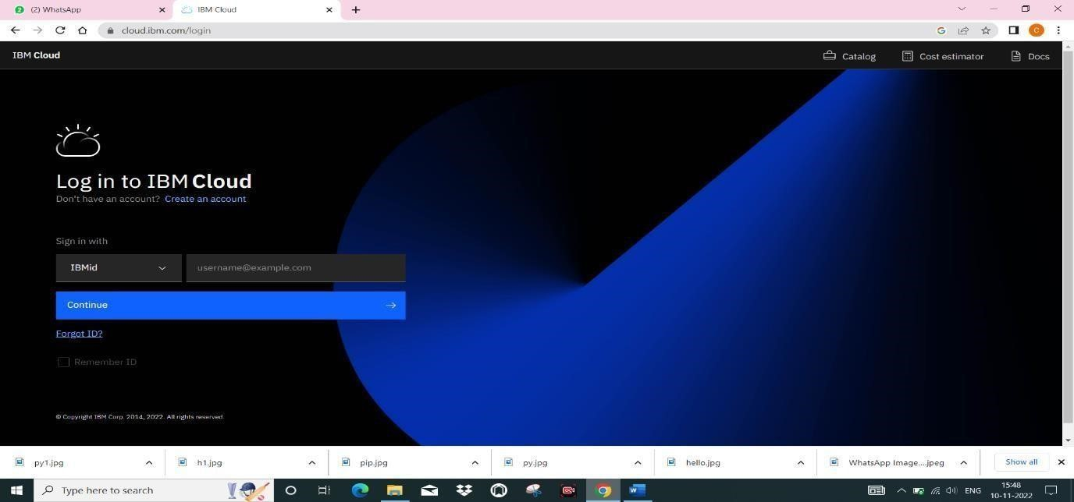

**Step 7:**

Finally, we can access the IBM cloud account!